Report of R/V Lawrence M. Gould Cruise LMG01-06

LMG01-06 report prepared by Daniel Costa and Chris Fritsen, with assistance from colleagues in the scientific party and the Raytheon Support Services.
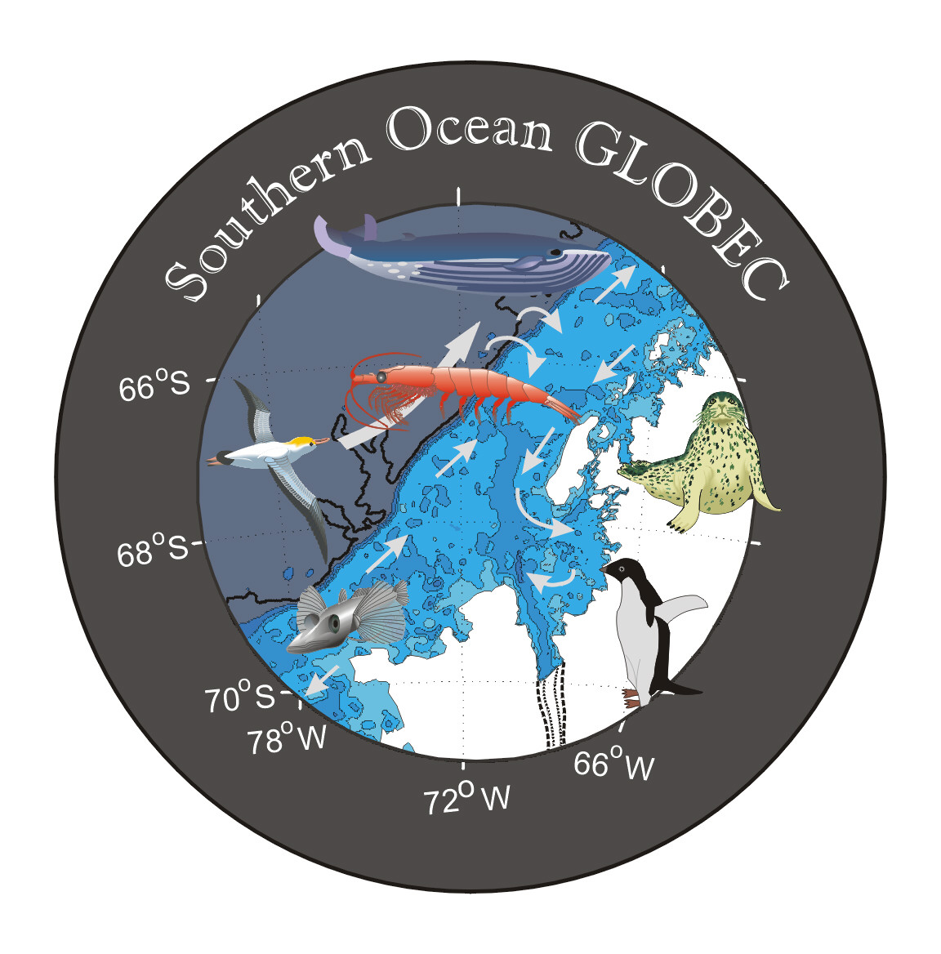
Report of
R/V Lawrence M. Gould Cruise LMG01-06
to the
Western Antarctic Peninsula
21 July to 1 September 2001

United States Southern Ocean
Global Ocean Ecosystems Dynamics Program
Report Number 3

Available from
U.S. Southern Ocean GLOBEC Planning Office
Center for Coastal Physical Oceanography
Crittenton Hall
Old Dominion University
Norfolk, VA 23529

Sponsored by Office of Polar Programs, National Science Foundation




Acknowledgments

The success we enjoyed on this expedition is due in large part to the very excellent technical assistance we received from the four members of the Raytheon Marine Technical support group. Led by Karl Newyear (Marine Project Coordinator), they responded to a wide variety of technical challenges as well as the uncertainties produced by the weather and ice. The ship’s officers and crew were outstanding as they provided excellent ship handling, in the sea ice and over the water. We especially grateful to Captain Robert Verret, he his easy going yet professional manner that was evident throughout the ship. It made this expedition a pleasure to be on.

LMG01-06 Cruise Participants on the Stern of the R/V L.M. Gould
(see facing page)

Bottom row: (from left to right) Dan Costa, Shonna Dovel, Sharon Stammerjohn, Charlie Boch, Gitte McDonald, Stephanie Oakes, Angela Gibson, Stian Alesandrini

Middle row: (from left to right) Jeramie Memmot, Sarah Marshal, Bruce Elder, Se-Jong Ju, Nick Gales, Tim Newberger, Langdon Quentin, Rodger Harvey, Peter Martin, Aaron Morello, Mike Thimgan

Back row: (from left to right) Karl Newyear, Chris Fritsen, Kerry Claffey, Bill Fraser, Steve Muth, Jordan Watson, Steve Trumble

Not Shown: Josh Spillane

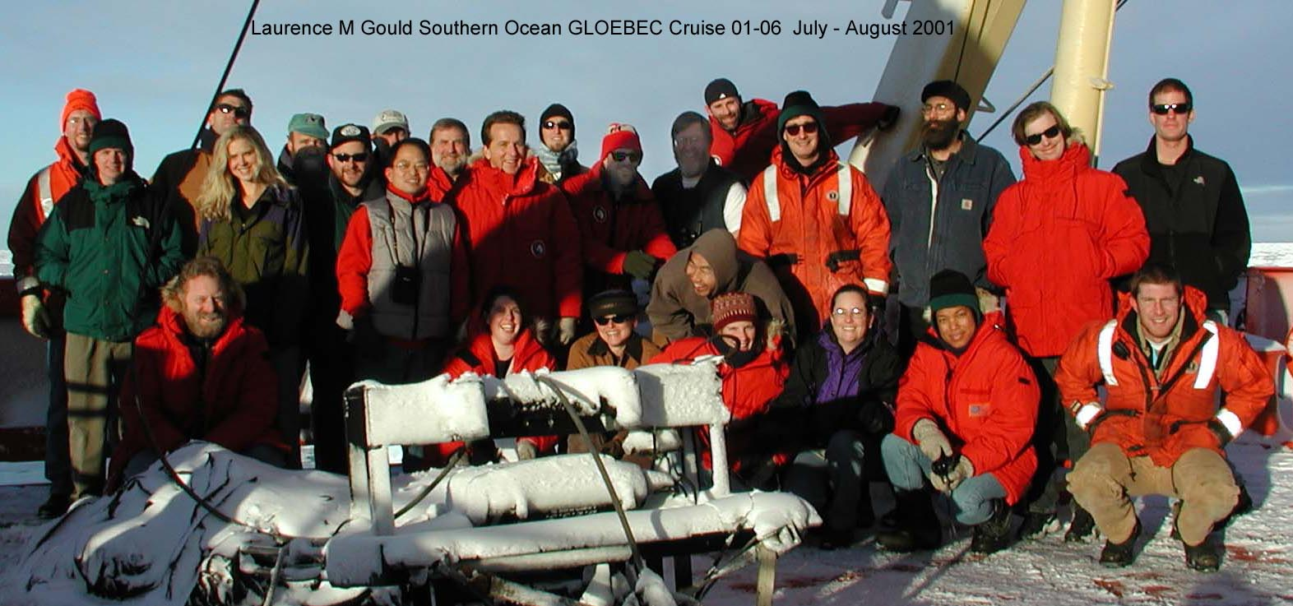

LMG01-06 Cruise Participants

TABLE OF CONTENTS

PURPOSE OF THE CRUISE 208
CRUISE NARRATIVE 210
INDIVIDUAL PROJECT REPORTS 217
BG-232 Costa, Burns, and Crocker 217
BG-234 Fraser 223
BG-235 Fritsen 224
BG-237 Harvey 229
BG-244 Quetin and Ross 231
OG-241 Martinson, Perovich, and Smith 231
CRUISE PARTICIPANTS 234
APPENDIX 1- Event log
APPENDIX 2- Passenger List

PURPOSE OF THE CRUISE

The U.S. Southern Ocean Global Ocean Ecosystems Dynamics (U.S. SO GLOBEC) Program is in its first field year. The focus of this study is on the biology and physics of a region of the continental shelf to the west of the Antarctic Peninsula, that extends from the northern tip of Adelaide Island to the southern portion of Alexander Island and includes Marguerite Bay (Figure 1). The primary goals of this program are:

1) to elucidate shelf circulation processes and their effect on sea ice formation and Antarctic krill (Euphausia superba) distribution; and
2) to examine the factors that govern krill survivorship and availability to higher trophic levels, including seals, penguins, and whales.

The field program consists of a three cruises a mooring cruise in March and April 2001 aboard the ARSV L.M. Gould, followed by two joint cruises occurring in April-May and July-August 2001 onboard the RVIB N.B. Palmer, which carried out a broad scale survey, and the ARSV L.M. Gould, which conducted process-oriented studies. The mooring cruise placed a series of moorings across the continental shelf off of Adelaide Island and across the mouth of Marguerite Bay, and a series of bottom-mounted moorings instrumented to record marine mammal calls and sounds were placed along the shelf. An equivalent set of joint cruises are intended to take place at approxaimtely the same times in 2002. The primary goal of this cruise was to provide a more detailed examination of the biological and physical processes that are occurring during this period of time. These data can then be put into the shelf-wide context supplyied by the broad scale survey work being carried out at the same time on the RVIB N.B. Palmer.

Our specific objectives were to:
- Measure the optical properties of the predominant sea ice types in the Marguerite Bay area. Quantify what the sea ice types are and measure their physical characteristics, which have a direct effect on the optical properties. Deploy drifting ice platforms to measure a long-term mass balance history of the sea ice cover over a 1-2 month period.
- Assess the distribution and activity of the sea ice microbial communities in order to determine the stocks and dynamics of the food reserves for krill over wintering in association with sea ice.
- Link the variability in the biological and physical characteristics of the sea ice habitat with the distribution and abundance of larval krill, and the diet and growth of larval and juvenile krill in winter.
- Apply recently developed biochemical approaches to determine the age structure of E. superba in field populations.
- Investigate specific lipids in E. superba as molecular markers of diet history and their potential as markers of trophic transfer.
- Use ARGOS-based satellite transmitters (PTTs) to determine the distribution and movements of important krill predators, Ad☺lie penguins and crabeater seals, relative to features such as bathymetry and sea ice.
- Employ a variety of diet sampling techniques to determine the winter foraging ecology of these predators, and particularly their impacts on krill life history stages and size classes.

Figure 1. Study region showing cruise track and scientific activities for LMG01-06.

CRUISE NARRATIVE

21 July
After considerable last minute preparations, the L.M. Gould departed on time from Punta Arenas, Chile at approximately 1755 local time (LT) on 21 July 2001 to begin the U.S. SO GLOBEC Process II cruise. Almost all of our gear and personnel made it safely to Punta Arenas. Unfortunately, a shipment of lithium batteries for the Martinson/Perovich/Smith program was held up on the Argentine border by a trucking strike. However, Bruce Elder was able to come up with a workaround so they are set to go. Unfortunately one of the two Raytheon Electronics Technicians was not able to make the cruise. The electronics technician from the N.B. Palmer (Dave) stayed on board to help with the final preparation and disembarked with the pilot at the eastern approach to the straits, and we then turned south for the Western Peninsula region of the Antarctic continent. Once under way we enjoyed good weather and calm seas as we approached the Strait of La Maire and the entrance to the Drake Passage.

22 July

The second day we steamed along the eastern coast of Argentina and cleared the tip of South America, making about 9 kts. In the morning the weather was quite pleasant. The presence of a particulary stable high-pressure cell of 1019 mb gave us light seas with moderate winds of 15-20 kts out of the southwest. In the morning, there were high mountains to the west of our course with their tops shrouded with clouds. Then in the afternoon, we steamed through a fairly narrow strait at the southern end of Argentina, where the mountains rose steeply out of the sea on both sides of the ship (really quite beautiful and wild looking). There was a lot of sun mixed with clouds throughout the day. The air was cool, around 5°C to 8°C.
23 July
The L.M. Gould continued across the Drake Passage towards Palmer Station via the inside passage route. We did not conduct a XBT transect during this cruise. We exited the sheltered waters of the Straits of Magellan and the east coast of Tierra del Fuego, and encountered significantly more ship motion than previously experienced in the sheltered waters of the straits or in the lee of Tierra del Fuego.

24 July
The L.M. Gould continued across the Drake Passage, which treated us reasonably well, though with a fair bit of rolling due to beam seas. While en route Karl Newyear deployed two NOAA Technoccean global drifters. The L.M. Gould crossed 60^{ο}S latitude earlier this morning, and this afternoon we sighted the first sea ice. There were loose bands of heavily decayed brash ice near 62^{ο} 10′ S. We initiated daily radio communications between the L.M. Gould and both Palmer Station and the N.B. Palmer.

25 July
The southbound transit of the Drake Passage was largely uneventful. Our route took us along the inside passage through the Gerlache Strait and the Neumayer Channel, though foggy conditions prevented much sightseeing. Although we were within sight of Palmer Station at approximately 1700 LT, it took almost an hour to reach the dock, as the dock was heavily covered with ice. After considerable effort Captain Verret skillfully maneuvered the L.M. Gould to the dock. We spent the evening enriching the Palmer Store with cash and enjoyed the Station's warm hospitality.

26 July
Cargo offload began at first light (0830 LT) and continued well into the afternoon. Various science groups took advantage of the facilities a Palmer Station for science preparation. Many individuals enjoyed the walk up the glacier behind Palmer Station. The L.M. Gould departed Palmer Station at approximately 1625 and began steaming towards the SO GLOBEC process site 1.

27 July
Our progress was slowed considerably by pack ice of varying thickness and concentration with several icebergs visible.

28 July
The L.M. Gould arrived at SO GLOBEC process site 1 early this morning through relatively heavy sea ice but without requiring assistance from the N.B. Palmer, which was nearby. The sea ice conditions prevented us from using the 1-m² MOCNESS so we waited until just before first light to conduct a CTD cast then proceeded with SCUBA diving and sea ice coring operations. The day was concluded with another CTD cast.

29 July
Today we proved that the L.M. Gould could penetrate the pack ice off of Adelaide Island under its own power in winter as we crossed the Antarctic Circle. Early this morning we made a rendezvous with the N.B. Palmer and exchanged some equipment via Zodiac. Science activities today included seal tagging, diving, our first MOCNESS tow, and a CTD cast. This area appears to be a biological hot spot that we considered using for SO GLOBEC process site 2. Fog throughout the day coated everything with a thick layer of delicate rime.
30 July
The L.M. Gould continued to occupy SO GLOBEC process site 2. We were very successful in gathering samples today despite deteriorating weather. An ice party spent most of the day off the ship on a large floe, the sealers delighted in collecting scat samples, and the krill teams deployed some 1-m² plankton nets as the ship drifted at ~0.7 kts in high winds. The first Ad☺lie penguin of the trip was netted, tagged, and released, and later that evening, we caught and deployed an additional 5 satellite tags on Ad☺lie penguins. We carried out a 1-m² MOCNESS tow later that evening.

31 July
The L.M. Gould has had a rather slow science day, with most of the time spent in transit from a rich biological site that was occupied for only one day towards process site 2 proper. We were able to tag a total of 6 Ad☺lie penguins yesterday prior to moving off the southwest coast of Adelaide Island. We had a reality check today, as Captain Verret has been able to maneuver the L.M. Gould through a wide variety of sea ice conditions. However, the sea ice conditions finally caught up with us, as we could not make further progress due to ice pressure. We notified the N.B. Palmer that we would probably need their assistance to get out. After only two hours, Captain Verret was able to free the L.M. Gould from the pack ice and we were underway under our own power. We then proceeded back to the open waters directly south of Adelaide Island.

1 August
We traveled along the pack ice edge in a localized polynya southeast of Adelaide Island in northern Marguerite Bay. We have seen very few seals but the weather has improved markedly. Our next planned rendezvous with the N.B. Palmer will occur in 2-3 days near SO GLOBEC survey site 28. Meanwhile we will work the southern Adelaide Island area. We carried out a XBT transect and a 1-m² MOCNESS tow across the polynya in the northern region of Marguerite Bay. We spent the afternoon looking for seals. We succeeded in spotting two leopard seals and 2 crabeater seals. An attempt was made to place a satellite tag on one of the crabeater seals, but it retreated into the water before the animal could be captured. As dusk set in the sea ice teams began sampling the sea ice. This will be followed with a CTD cast. The next day or two will be spent looking for predators in the vicinity of Adelaide Island. After this we plan to get the assistance of the N.B. Palmer to take us to process site 2 that is further into the mouth of Marguerite Bay. Once there we hope to deploy a complex ice drifting buoy and set up a multiple day process station.

2 August
The L.M. Gould continued to operate in open water/ice edge region to the south of Adelaide Island. Seals were sighted, including a few Weddell seals, but very few crabeaters were hauling out on floes accessible to the scientists. Nevertheless, we handled and tagged our second seal of the cruise yesterday. We also completed a CTD cast, collected sea ice, and completed a MOCNESS cast. The weather conditions continued to be good.

3 August
The L.M. Gould occupied an area near the southern end of Adelaide Island. We sent a shore party to Emperor Island, part of the Dion Islands, to census an Emperor penguin colony there. This is the northernmost known breeding colony of Emperor penguins and the only place where that species is known to breed on land. Ten males, 9 with eggs, were sighted; the females are at sea feeding this time of year. This is approximately half the number of birds seen in the same place two years ago. Workable seal sightings remained few and far between.

4 August
Sustained winds of 50 kts with gusts to 60+ kts forced us to suspend science operations for the day. We sought refuge via invitation at Rothera Station and received a warm welcome, literallyair temperatures were several degrees above freezing! Our stay in the banana belt of the Peninsula lasted only about four hours before we were underway again. However, several scientific collaborations with the British Antarctic Survey were hatched during our visit. As we departed the area we completed a CTD cast east of Jenny Island as part of Rothera's long term monitoring project. We then steamed towards a rendezvous with the N.B. Palmer.

5 August
In the morning the L.M. Gould and N.B. Palmer made a rendezvous off the southwest coast of Adelaide Island. The Gould transferred two "simple" Cold Regions Research and Engineering Laboratory (CRREL) ice buoys to the N.B. Palmer for placement at locations that the Gould will not visit. The N.B. Palmer then assisted in placing the Gould at process station 2, which is near SO GLOBEC survey station 42, in the mouth of Marguerite Bay and situated over the submarine canyon leading into the Bay. Once in place the scientists put in a full afternoon's work with one crabeater seal being tagged, and one SCUBA dive and a full sea ice transect completed.

6 August
The L.M. Gould remained on station at process site 2 throughout the day. Sea ice conditions were such that we were able to put the gangway out and parties have been able to come and go at will. Thirty to 40 cm of sea ice was overlaid with 10 cm of heavy wet slush and 20 cm of snow. Science operations began at around 0900 in the morning and the last groups returned to the ship from the ice at about 2100. Every group was able to collect samples except for those seeking penguins or needing to tow the MOCNESS. We even cut a hole in the sea ice to allow a CTD cast to be completed. A precipitous drop in air temperature and wind speed helped make operations more comfortable today than yesterday. A number of crabeater seals remained in the area, allowing the seal team to deploy two additional satellite linked time-depth recorders, giving them a total of 5 tags deployed so far.

7 August
The L.M. Gould continued to occupy SO GLOBEC process station 2. The past 24 hours have brought highly variable winds and dropping temperatures. Colder weather was a blessing because since it allowed sampling of sea ice throughout the freezing process. It also froze the 10-cm slush layer on top of the sea ice so we did not have to slog through ankle-deep slop to get to the sampling sites. However, ice and wind conditions prevented us from using the CTD hole that was cut in the sea ice yesterday. This was because we were unable to reliably keep the hole aligned with the Baltic room door. It was a rather slow science day with the ice collectors being the most active group. No workable seals or penguins were sighted. One significant problem developed today in that due to the very cold weather, the Radvan turned into a freezer van as it was no longer capable of maintaining proper temperature. In fact the temperature dropped to less than -10ºC. This caused a number of stock solutions to freeze! All experiments for primary production and secondary bacterial production were halted until we were able to solve this problem. Fortunately, a temporary fix was achieved by installing an additional wall heater along with several space heaters. These heaters coupled with warmer temperatures has at least for now solved the problem.

8 August
The L.M. Gould remained on site at process site 2. Continued cold temperatures with wind chill occasionally dropping below -50ºC kept outdoors operations somewhat to a minimum yesterday, though things began to slowly warm up with a northerly wind. Science proceeded well, and our challenge was to keep laboratory spaces at their proper temperatures. We anticipate spending at least two more days at this location before moving to the southwest.

9 August

The L.M. Gould is still making productive use of our time at process site 2 with diving and sea ice sampling operations occurring during daylight hours. The air temperatures have risen considerably but snow is accumulating. This depresses the sea ice under its weight and leads to intrusion of seawater and re-formation of a slush layer between the dry snow and the sea ice. Due to limitations on the L.M. Gould we have altered our science plan so that we will move to the northeast of here rather than the southwest in about 2.5 days. The ice sampling crew sighted a seal in the afternoon. This allowed the seal team to successfully deploy their sixth satellite time depth recorder on a male crabeater seal. This was done while the wind was blowing 30 kts with the air temperature a balmy –2.0C.

10 August

The L.M. Gould was forced to relocate slightly from process site 2 by a large iceberg heading directly towards us. We pulled up our stakes but left the complex CRREL buoy in place to be recovered during NBP01-06. Upon moving approximately 1.5 km from our previous work site, we conducted a CTD cast and decided to find a suitable site for about 2 days more work. While doing so we came across a group of Ad☺lie penguins that were captured for diet sampling. We also came across a seal but it went into the water. Teams collected sea ice samples.

11 August
After collecting diet samples from Ad☺lie penguins last night, the L.M. Gould continued to move in the immediate vicinity of process site 2 to find a suitable, iceberg-free location for more work. In the process we became stuck for several hours in an area of ice pressure and active ridging. Around midnight we broke free and hove to in an area of thinner sea ice. At first light we identified a suitable floe for sea ice collections and diving operations and set up camp. At approximately 1500 we were forced to pull up stakes once again as winds caused the ship to move to starboard and crack the working floe. However, we were able to complete one dive and an ice thickness transect before we had to move.

12 August
At daylight when the L.M. Gould attempted to move to a good location to conduct science we were unable to make any progress due to sea ice pressure and heavy ridging in our vicinity. Meanwhile, some repairs were necessary on the main engines. These two conditions led to the daily metric of UD. Nevertheless, the ice coring team was able to collect some samples.

13 August
The L.M. Gould spent the morning maneuvering into position for a rendezvous with the N.B. Palmer. At approximately 1425 LT, the two vessels met and the Palmer led the way north through heavily rafted sea ice and extensive rubble fields for the Gould. At (1600 LT) the two ships exchanged equipment and then parted ways. The Palmer was to pick up where they left off on their survey grid, while the Gould planned on spending time in the open water near the southern end of Adelaide Island looking for predators and towing the MOCNESS net.

14 August
The past 24 hours have brought us the most extreme weather we have seen yet. The barometer bottomed out at 936.5 mb, the air temperature dropped to -27.8□C (wind chill of -55 to -60□C), and we had zero visibility last night due to blowing snow in 40 kt winds. The L.M. Gould thus hove to while awaiting the return of the N.B. Palmer to escort us further north. At first light this morning we continued our northward push through heavily ridged pack ice. It is hard to believe that a week ago this area had only 4 inches of sea ice with 4 inches of snow on top! No science is being planned or conducted during this transit to our study area. Active discussions are taking place both on board and between the two ships as to what the best plan for the remainder of the cruise will be.

15 August
The N.B. Palmer succeeded in escorting the L.M. Gould to our desired station location last night. The two ships parted ways again at approximately 2230, with the Palmer returning to the south and the L.M. Gould remaining near survey station 19 to establish another process site. At first light this morning we nosed around the weakly cemented floes looking for an ideal location when a seal was sighted. The seal team handled the animal, then we conducted a CTD cast, and began work on the sea ice. Cold temperatures and weak winds made it relatively easy to work outside.

16 August
The L.M. Gould continues to occupy SO GLOBEC process site 3 with good success. Three SCUBA dives were completed today along with extensive sea ice coring and collection. We were visited by a lone Emperor penguin this afternoon, but the birders did not handle it. The ship requires close care to keep it alongside the working floe as the pack ice is loose, but remains at 10/10 coverage. Light winds and cold temperatures make for good working conditions.

17 August
The L.M. Gould continues to occupy process site 3. As an experiment, we erected a Scott tent over one of the two dive holes. Overnight, there was enough freezing on the unprotected hole to walk across, while on the covered hole the sea ice was so thin you could put your finger through it. The tent also provided shelter against the wind for the tenders and helped to cut down on glare and visual shock for the divers coming out of a darker environment. Air temperatures continue to be cold, but offshore winds should help relax the sea ice pack making it easier for the L.M. Gould to move about the area under its own power.

18 August
The L.M. Gould continues to occupy SO GLOBEC process site 3. Sea ice collections and dive operations are being conducted and we have seen no seals or penguins lately. The news of the day is the rise in air temperature from around –20□C to near –5□C. We are also experiencing a rather noticeable swell running though our area but the working ice floe is holding together.

19 August
Visibility is very poor due to falling and blowing snow. Nevertheless, we are continuing to collect sea ice and brine samples and to measure an ice thickness transect. Conditions are judged to be too poor to allow for safe SCUBA diving. Work was completed at process station 3 today. The plan is to move to the east and/or north tomorrow during daylight. This will allow us to search for seals and penguins as well as hopefully find open water to tow the 1-m² MOCNESS.

20 and 21 August
The plan for the day was to steam towards Adelaide Island in an attempt to find open water to carry out some final MOCNESS tows and to look for penguins for diet sampling and a final seal to tag. Prior to departure we completed a CTD cast and then steamed to the north looking for leads that would allow us to move to the east. It was slow going. We had to back and ram multiple times and our speed was only 2 kts. When we left our process station we were 17 miles from our planned waypoint, when we shut down in the evening we had 11 miles left to the waypoint. During the night we had considerable winds from the northeast, such that by morning when we started again we were now 22 miles away from our waypoint! However, the sea ice team was able to get samples from this station.

22 August
The L.M. Gould hove to for the night, then conducted a SCUBA dive in the morning before moving on towards the east-southeast. Progress is rather slow due to 50-60 cm thick sea ice but we are seeing bits of open water. In the afternoon we sighted a group of Ad☺lie penguins that appeared to have already fed today. However, they escaped into the water before we were able to corral them to obtain stomach samples.

23 August
Yesterday our progress was slow and we were finally frustrated in our attempts to cross a field of heavy rubble off the coast of Adelaide Island. We hove to for the night and re-thought our options. Before breakfast we collected sea ice, then turned to the north to head for the seaward ice edge. The latest satellite images indicate that at our current progress of 4 kts we should reach relatively open water by tomorrow morning. While en route today we are continuing to look for fed penguins.

24 August
The L.M. Gould ran through the night and made good progress to the north. We are now in an area of pancake ice with occasional open water and can move about at will. We are conducting sea ice sampling en route to an area off the west coast of Reynaud Island. This is a known area of Ad☺lie penguin feeding during the summertime, but no one has visited it in the wintertime. We also witnessed a leopard seal actively stalking a crabeater, which was hauled out, on a floe, but there was no attack.

August 25
The L.M. Gould made its way northeastward throughout the night and got into position near French Passage, south of LeMaire Channel. At daylight we began preparations for our first attempt at a 1-m² MOCNESS tow in nearly three weeks. Unfortunately the tow was not as successful as we would have hopedthe catch consisted of only a few juvenile krill and the MOCNESS was slightly damaged in a collision with an ice floe. Repairs were made as necessary and we conducted another tow in the afternoon but no more adult krill were caught. We are anticipating an arrival at Palmer Station around noon tomorrow.

26 August

The L.M. Gould discovered last night that the LeMaire Channel was impassable due to sea ice. We therefore took the outside route to Palmer Station and were tied up to the pier by 1030 this morning. Cargo operations began immediately under the threat of deteriorating weather and went quickly. The weather held, and we are anticipating an evening of hospitality ashore.

27 August

We finished our visit at Palmer Station and left the dock at 1100. We had absolutely beautiful weather as we steamed through the Neumar Passage!

28 August

The L.M. Gould arrived at Deception Island around 0600 this morning and our first Zodiac departed for shore by 0845. We were in search of cryptobiotic soil for one grantee's Life in Extreme Environments (LExEn) project as well as for a look around the old whaling station in Whaler's Bay. The weather was less than perfect, with occasional snow and 30 kt winds, but no one seemed to mind too much. We are now en route back to Punta Arenas, Chile.

29 August

The L.M. Gould continues on its trip home across the Drake Passage. We made a northbound crossing of 60S latitude this morning and have now officially departed from Antarctica. We anticipate an on-time arrival in Punta Arenas, Chile.

30 August

The L.M. Gould continues on its northward crossing of the Drake Passage. We passed through the Straits of La Maire between Cabo San Diego and Isla de los Estados at the southeastern tip of Tierra del Fuego and are anticipating an on-time arrival in Punta Arenas, Chile.

31 August

The L.M. Gould entered the Strait of Magellan this morning and we are currently awaiting the arrival of the pilot boat. We will arrive at the pier in Punta Arenas, Chile around midnight tonight, a few hours ahead of schedule.

INDIVIDUAL PROJECT REPORTS

BG-232 Costa, Burns and Crocker

Field team D. Costa, N. Gales, S. Trumble and B. McDonald

The Antarctic marine environment undergoes considerable inter- and intra-annual variability, resulting in marked variation in the spatial and temporal availability of prey for vertebrate predators. Although we know that oceanographic features are necessary to concentrate or aggregate prey, the specific relationship is poorly understood. Crabeater seals offer a unique opportunity to better understand the foraging strategies utilized by marine predators in the face of meso- and fine-scale ecological variability. Within the seasonal pack ice zone crabeater seals prey almost exclusively on Antarctic krill (Euphausia superba). Yet despite their reliance on a locally abundant and spatially heterogeneous prey resource, crabeater seals are the most abundant Antarctic pinniped (ca. 15 million). Our goal is to understand how crabeater seals forage on krill within the seasonal winter pack ice. Data on krill distribution and abundance acquired as part of the Southern Ocean GLOBEC field program and the biophysical coupling will provide a context in which to place the foraging behavior of crabeater seals. A total of 16 (8 tags in the fall cruise and 8 tags on this cruise) satellite-linked time-depth recorders have been placed on crabeater seals to monitor their foraging patterns (locations and dive patterns). Our field team on this cruise consists of Dan Costa (University of California Santa Cruz), Nick Gales (Australian Antarctic Division), Steve Trumble (University of Alaska), and Brigitte McDonald (Sonoma State University). Fortunately we had the able assistance of Steve Trumble, who was part of the previous crabeater field team on the April-May U.S. SO GLOBEC cruise, LMG01-04.
During the first few days of the cruise we saw very few seals either in the water or hauled out on ice floes. Although the initial lack of sightings was frustrating, we were buoyed by the daily location updates we received from the eight seals tagged on the earlier U.S. SO GLOBEC cruise. These animals were diving very deep, and provided us with a new maximum depth for the species of 605 m! While in transit after tagging our first seal, we encountered over 200 crabeater seals hauled out along a large lead running along the west coast of Adelaide Island. We decided to stay there for the night, to allow seal tagging during the next day. Unfortunately, by dawn the weather had deteriorated (-2^{ο}C, 30-40 kt winds with gusts up to 50 kts) and the seals preferred to stay in the water. The seals did not haul out and we witnessed groups of them swimming in open leads near the ship. We were able to collect five scat samples from the area were the seals hauled out and although the material was very digested the only prey item found was krill.
Over the next few days, we spent considerable time looking for hauled out seals in the northern reaches of Marguerite Bay. Although we spotted several leopard and Weddell seals hauled out, we saw very few crabeater seals and those that we did see were either in the water or immediately went into the water as we approached. When we stopped looking for seals and departed for process station 2 (5 August) we were quite concerned, as the information from our tagged seals indicated a consistent movement to the north, with no animal remaining in the southern reaches of Marguerite Bay. In fact only one of our ten tagged seals even remained in Marguerite Bay, while all the others had moved north along Adelaide Island to Crystal Sound. However, we were pleasantly surprised that, upon arriving at process site 2, we discovered at least 13 animals hauled out. While at this station we successfully tagged four crabeater seals. Of the two remaining animals one was tagged at process station 3 and the other while in transit. A major lesson learned was that our work could be carried out both a process stations and while in transit actively looked for seals and penguins.
One problem we faced was working in the cold and wind. We had problems with some equipment not working well in the cold and had to come up with novel approaches to keep it warm. For example, the jab stick that we used to administer the anesthetic would not release below –5°C, the Evans Blue dye would freeze prior to injection, and the 5-minute epoxy would not flow. We found that small hand warmer packs strapped around the epoxy cartridges, and/or keeping the injectable materials in insulated bags with hand warmers solved most of these problems. Using these and a variety of other tricks we found we were able to work in temperatures as low as –18°C as long as the wind was less than 20 kts. We found we could work in the wind but it made it much more difficult. We also found we could work at night as long as the L.M. Gould was nearby. The ship's spotlights provided plenty of light at reasonable distances. The addition of small headlamps filled in the shadows making night work quite reasonable. Our last seal was initiated after sunset.
Given the results from the first cruise, we were able to fine-tune our data collection strategy for collection of the satellite-linked dive behavior data. ARGOS has a very limited bandwidth and the tags produced by the Sea Mammal Research Unit have a very sophisticated data compression scheme to maximize the most efficient transmission of information. For the fall cruise, this compression scheme relied on the published literature on crabeater seal diving behavior to come up with a data compression algorithm. During the fall U.S. SO GLOBEC cruise, we found that we could get a higher data uplink rate than expected and thus a higher probability of receiving dive data in both a concise and a detailed form. When sending both concise and detailed dives the best data coverage we could expect was that 90% of the dives would be covered in concise form (maximum dive depth and duration only) with 30% of the dives in detailed form (able to reconstruct the actual dive profile). Given the high uplink rate observed in the fall 2001 cruise, we were able to modify the data collection strategy for the winter 2001 cruise accordingly so that we now receive close to 80% of the dives in detailed form.
An essential component of this project is the safe and predictable handling of the experimental animals. To this end Dr. Nick Gales, a veterinarian and researcher from the Australian Antarctic Division, assisted us with the development of an appropriate restraint technique for crabeater seals. Any restraint methodology must ensure safety to the personnel and the animal, as well as facilitating normal post-recovery behavior of the seal during the experimental period. To this purpose a novel suite of tools were used. Firstly a conical shaped net with a hole at the apex and multiple layers of net around the apex was utilized. When the animal was contained in the net, its muzzle protruded through the hole and was kept closed by the tight fit. This enabled access to the nose for anesthesia purposes as well as ensured that no personnel could be bitten. Prior to netting, the seals were administered a high dose of the sedative midazolam. This was given via a pole syringe and, after a 20-30 minute period, provided a level of sedation that enabled safe physical restraint for induction of full anesthesia. For the first time ever a winterized gas anesthetic machine was used to achieve full chemical restraint. The gas anesthetic isoflurane is among the safest chemicals to use as an anesthetic. The problem with its use in low temperatures is achieving adequate gas concentrations. A modified veterinary gas anesthetic machine, with a closed, re-breathing circuit, was built into an insulated box and thermostatically controlled heating systems were designed and incorporated into the box. Prior to each anesthetic episode the machine was pre-heated to 25-28°C. During the 2-3 hours in the field the internal box temperature dropped only about 2°C. Anesthetic induction and maintenance was achieved with a face mask that fitted with an almost airtight seal around the animals exposed muzzle. Each anesthetic was monitored closely, a handheld CO₂ monitor being an important addition for this purpose. Anesthetic durations were kept as short as was practical, this being a second important component of the safety of the procedure. The result of the combination of midazolam sedation and isoflurane anesthesia was a safe, repeatable and predicable gas anesthetic protocol suitable for ice-seals. Induction and recovery times were short. All anesthetic equipment (>US$8,000 worth of specifically built or purchased instruments) were provided at no cost to this program by Nick Gales of the Australian Antarctic Division. This system will be published, and we believe represents an important development (methodologically and ethically) in ice-seal handling protocols.
The maximum dive depth observed during our cruise was 545 m (Table 1) just slightly less than the 605 m measured for the animals tagged during the fall U.S. SO GLOBEC cruise. However, their routine diving depth is shallower, working anywhere from 150-300 m (Figures 2 and 3). There has been a significant movement to the north of all of the animals (Figure 4). Three of the 4 seals that were tagged at process site 2 worked the same general area, but then moved to the north. Only one animal (KJ) currently remains in this area, while one animal moved into Marguerite Bay and then moved north along the east side of Adelaide Island going through Tickell Passage into Crystal Sound. The remaining animals all moved north along the west coast of Adelaide Island into Crystal Sound and along the Biscoe Islands. One animal (Ryan) moved all the way to Anvers Island.
Bloods samples were collected from each crabeater seals using standard field procedures. Samples were analyzed on the L.M. Gould for Hemoglobin content (oxygen carrying capacity of the red blood cell) and a complete blood count (red and white blood cells and platelets). Blood smears were made on the Gould for differential blood count, and erythrocyte morphology. In addition, frozen plasma or serum samples are being returned for determination of standard plasma chemistries: sodium, potassium, chloride, calcium, phosphate, cholesterol, glucose, protein, blood urea nitrogen, albumin, creatinine, globulin, bilirubin, lactate dehydrogenase, alanine aminotransferase, aspartate aminotransferase, creatinine phosphokinase, gammaglobulin transferase, and alkaline phosphatase. We also measured the blood volume of these animals by use of the Evans Blue dye technique, which provides (along with muscle myoglobin, Hct and Hb) a measure of the total oxygen stores of each seal. These data, along with dive profiles, are essential in assessing the foraging ecology of the crabeater seal. Blubber and muscle biopsies were taken. The muscle samples will be used to assess the oxygen carrying capacity of muscle. The blubber sample will be analyzed for it’s free fatty acid composition to provide an index of each seals diet. Diet analysis (trophic level) will also be supported with stable isotope analysis of whisker samples that were collected from each seal.
A series of morphometric measurements was used to assess the relative body composition and therefore condition of each seal. This was done by measuring the blubber thickness, using a portable ultrasound scanner, at five sites along the animal's length. These measurements will be coupled with girth and length measurements at each site to allow a reconstruction of the animal as a series of truncated cones. These combined measurements will be used to calculate the body composition of the seal by treating the seal as a series of truncated cones.

Table 1. Summary of the tag number, name, sex, morphometric data, date animal tag, location tagged and time from capture to release of the eight crabeater seals collected during this cruise.

Tag # | Name | Sex | Mass | Length (cm) | Girth (cm) | Date | Max | Location tagged |  | Time
 |  |  |  | Std | Axillary |  | Depth (m) | Latitude | Longitude | Capture | Release
G011 | Jimmy | M | 232 | 214 | 155 | 7/29/2001 | 545 | 67° 13.6 | 69° 25.4 | 12:35 | 14:19
G009 | KJ | M | 179 | 221 | 131 | 8/2/2001 | 485 | 67° 43.9 | 69° 18.70 | 15:30 | 16:17
G010 | Jemma | F | 307 | 243 | 165 | 8/5/2001 | 445 | 68° 04.73 | 70° 21.41 | 12:56 | 14:02
G012 | Collie | F | 288 | 236 | 165 | 8/6/2001 | 405 | 68° 03.8 | 70° 10.5 | ~12:10 | 13:43
G013 | Robert | M | 234 | 216 | 148 | 8/6/2001 | 405 | 68° 04.2 | 70° 11.6 | 16:16 | 17:28
G014 | Ryan | M | 284 | 238 | 174 | 8/9/2001 | 325 | 68° 05.2 | 70° 05.2 | 16:01 | 17:20
G015 | Shawn | M | 234 | 218 | 150 | 8/15/2001 | 425 | 67° 10.57 | 70° 13.49 | 11:23 | 12:33
G016 | Anna | F | 273 | 231 | 156 | 8/21/2001 | 385 | 67° 23.76 | 70° 51.04 | 16:39 | 19:50

Figure 2. Diving record for seal Jimmy (July 29 to August 28 2001). This is first seal tagged and thus the longest record. Time is given in days of the month running along the long axis of the image. Depth is given in meters along the short axis going from 0 to 500 m. The deep blue lines are dives where dive profile data were collected (can reconstruct the actual dive shape). The white box shows the maximum depth recorded during each 6-hour period. The two lower graphs are swim speed in blue in m s⁻¹. There are 3 speeds shown, the first speed refers to the section of the dive up to the first inflection points. The last one is the speed between the last inflection point and the end of the dive. The lowest plot shows the relative time spent hauled out (green) diving (yellow) or in the water but not diving (blue). Image provided by Phil Lovell of the Sea Mammal Research Unit.

Figure 3. The dive track of the eight crabeater seals are shown in a pseudo three-dimensional image. The surface track incorporates the animals diving pattern where data are available. These data are placed in the context of the ocean bathymetry. The black lines show the world vector shoreline data, which don’t merge very well with the bathymetric data available for this area. Image provided by Phil Lovell of the Sea Mammal Research Unit.

Figure 4. The track of each animal from the time it was initially tagged through 28 August 2001 are shown. Each seal has a unique color. All tracks start at the southern end and move to the north. Of the eight seals, only one remained in the general area where it was tagged. Image provided by Phil Lovell of the Sea Mammal Research Unit.

BG-234 Fraser

Field team W. Fraser and S.Muth

Our research focused on identifying and understanding the processes that sustain the large wintering populations of Ad☺lie penguins in the Marguerite Bay region. Our field program was thus developed with two key objectives in mind. The first was to instrument penguins with ARGOS-based satellite transmitters (Platform Transmitter Terminals, PTTs) to determine their winter distribution and movements. The second was to use the PTT-derived data to identify key areas where penguins forage, and to investigate these areas to collect diet samples. This second objective met with limited success, as only five penguins were captured and lavaged during the cruise. Although the diet samples obtained were quite digested, we nevertheless were able to determine that males were feeding predominantly on krill and females on fish. This pattern was also noted in the May U.S. SO GLOBEC cruise, hence these preliminary winter diet data suggest the pattern continues into the winter. We fortunately will have another opportunity to obtain penguin diet samples in Marguerite Bay during September of this year when the Palmer Long-Term Ecological Research (LTER) cruise returns to the region to continue its long-term studies of western Antarctic Peninsula marine ecology.
The goals associated with our first objective were reached on 15 August when we completed the deployment of 12 PTTs. Although all 12 of these instruments are designed to provide data on penguin locations, two of the instruments also provide information on dive depth and other foraging parameters. All 12 of these instruments are operating flawlessly at this writing (Figure 5), and are providing a first look at some previously unknown aspects of Ad☺lie penguin winter foraging ecology. Among several patterns seen thus far, three are especially noteworthy. The first confirms the importance of winter sea ice to this species. In the Marguerite Bay region, the movements of Ad☺lie penguins closely track the advance and retreat of the ice edge, including the opening and closing of vast shore leads along Adelaide Island that develop in response to wind forcing. The second pattern, though based on limited data, suggests that male and female Ad☺lie penguins divide their foraging environment, with males feeding on krill at average depths of 180 m and females feeding on fish at average depths of 120 m. The last pattern clearly shows that the polynya that annually develops south of Adelaide Island is a focal point of predator activity in this region. Regardless of where in Marguerite Bay Ad☺lie penguins were instrumented, and this includes birds taken during the May cruise as well, all individuals eventually migrated to this polynya and remained associated with this feature during most of the study. A final and important point to make is that the deployed PTTs are programmed to continue delivering data for up to five months beyond the end of this cruise, a time period that will encompass much of the Ad☺lie penguin breeding cycle. To the extent that instruments continue to function properly, the resulting data will provide a unique perspective on winter-summer foraging movements.

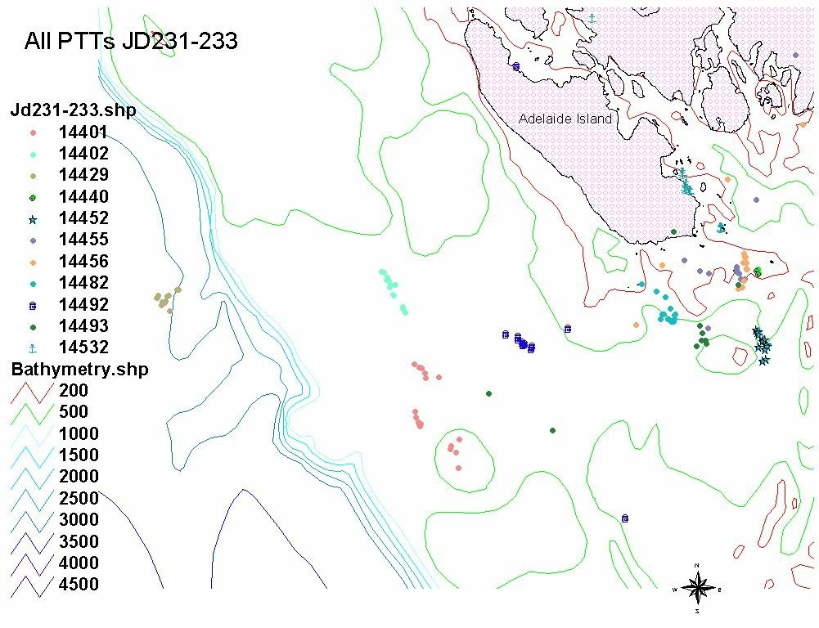

Figure 5. Unedited locations of PTT-instrumented Ad☺lie penguins in the Marguerite Bay region between 19-21 August 2001. With the exception of PTT 14429, a penguin foraging along the western boundary of the ice edge near the shelf break, all other PTT locations correspond with either wind-forced shore leads west of Adelaide Island, or a large polynya that developed south of Adelaide Island during the winter.

BG-235 Fritsen

Field team C. Fritsen, S. Marschall and J. Memmott

Aspects of the BG-235 program were implemented on both the process and survey cruises during July and August of 2001 for determining small-scale and mesoscale distributions and characteristics of microbial biomass and carbon production in sea ice. The objectives of the BG-235 program are being accomplished using an integrated combination of satellite imagery, underway observational protocols, small-scale ice, slush and snow sampling and experimental determinations of physiological rate processes. Descriptions and results of several stages of the BG-235 ice ecology program that were accomplished during the LMG01-06 cruise are outlined below.

Ice observations
Routine observations of sea ice and snow characteristics were routinely collected on an hourly basis while the L.M. Gould was actively steaming throughout the cruise. These observations began on 26 July 2001 and continued through 27 August 2001. The observational protocol followed during the cruise was the protocol that is formally endorsed by the SCAR ASPeCt (Antarctic Sea ice Processes and Climate) program for observing sea ice characteristics. In short, our program (combined efforts of BG-244 as well as OG-241) was able to gather the information that will be used to characterize the predominate types of ice in the region according to parameters, such as areal coverage, floe size, ice thickness, snow type, snow thickness and deformation.
These observations are being analyzed in conjunction with those collected by personnel on the N.B. Palmer to yield a regional ice maps. The summary data from the observations on the Gould show substantial amounts of open water were encountered during cruise as was evident from a large amount of time spent in the vicinity of the southern end of Adelaide Island where the reoccurring polyna predominated. Because of these operations, the operations are highly biased and significant editing of observations has to occur to account for reoccurring observations in the same region. Such editing and analysis are underway. Despite these known biases, the observations yield useful information in regards to the types of ice encountered. For instance, the average estimated ice thickness on ridged ice types was 54 cm while the average level ice thickness encountered was 38 cm (Table I). Snow thickness estimates yielded an average snow thickness of 11 cm with only 70.8% of the ice observed had snow (the remainder of the ice observed being nilas or young gray ice with new snow cover).

Table I. Summary statistics from sea ice observations aboard LMG01-06.

Total ice concentration (%): 82.18*
Open water within pack (%): 17.82*
Avg. level ice thickness (total area) cm: 31.52
Avg. level ice thickness (ice area) cm: 38.35
Fraction of surface area ridged: 0.05
Avg. ridged ice thickness (total area) cm: 44.50
Avg. ridged ice thickness (ice area) cm: 54.15
Avg. snow thickness (total area) cm: 9.05
Avg. snow thickness (ice area) cm: 11.01
Avg. snow thickness (snow covered area) cm: 15.55
Snow covered ice within pack (total area): 58.18
Snow free ice within pack (total area): 24.00
Percent ice with snow cover: 70.80
Percent ice with no snow: 29.20

Avg. albedo (total area) 0.55*

*biased by repetitive polyna observations

Ice stations
Ice floes were accessed from the LMG throughout the cruise for snow and ice studies that entailed such activities as ice and snow thickness transects, ice core collections, brine collections and instrument deployments (e.g., thermistor strings, radiometers, buoys) (Table 2).

Table 2. List of ice stations (numerical designation as well as common names) for the stations where physical, chemical and
biological studies were performed on sea ice and snow during LMG01-06 operations (compilation courtesy of S. Stammerjohn).

Ice | Ice | Start | End | Starting | Starting | Ending | Ending | Event | Brief Floe
Stat # | Station Name | Date | Date | Latitude | Longitude | Latitude | Longitude | Numbers | Description
1 | Process Site 1 | 7/28/01 | 7/28/01 | 66°22.0 | 70°43'.5 | 66°21'.6 | 70°43'.1 | 19-21 | 1st site - level 30-32cm GWI cake floe rafted to ridged 60-100cm FYI cake floe; 2nd site - level 30-32cm GWI 20-100m floe
2 | Arched Iceberg | 7/30/01 | 7/30/01 | 67°36'.3 | 69°22'.2 | 67°39'.8 | 69°20'.4 | 30-32 | semi-level 25-37cm young FYI 20-100m floe rafted to a ridged 25-200cm FYI 20-100m floe; flooded areas on ridged floe
3 | Leopard Seal | 8/1/01 | 8/1/01 | 67°49'.2 | 67°48'.0 | 67°49'.2 | 67°48'.0 | 55 | ridged/rafted 30-100cm young FYI cake floe
4 | Return to Flooding | 8/2/10 | 8/2/01 | 67°43'.9 | 69°18'.7 | 67°49'.5 | 69°18'.8 | 60-61 | flooded and rafted 15-55cm young FYI 20-100m floe
5 | Robert | 8/5/01 | 8/9/01 | 68°03'.8 | 70°21'.9 | 68°02'.0 | 70°06'.8 | 72, 76-77, 80-82, 86-88, 90-91, 93, 95, 97-98 | Initially flooded, highly ridged/rafted 25-200cm young FYI 100-500m floe; observed cycles of flood/freeze during 5 day stay
6 | Fernando | 8/11/01 | 8/11/01 | 68°05'.5 | 69°41'.5 | 68°05',5 | 69°41'.5 | 104-105 | highly flooded, ridged 35-50cm FYI 20-100m floe
7 | Backbend | 8/12/01 | 8/12/01 | 68°12'.3 | 69°31'.4 | 68°12'.3 | 69°31'.1 | 107-108 | level 45cm FYI cake floe rafted to ridged 45-100cm FYI cake floe; heavy flooding in rafted area near ridge
8 | Billy | 8/15/01 | 8/19/01 | 67°10'.7 | 70°14'.1 | 67°17'.5 | 70°39'.8 | 111, 113, 118-119, 121, 123-124 | level 20cm GWI cake floe rafted to a highly ridged/rafted 50-240cm FYI cake floes; observed snow loading of up to 20cm, freeboard depression of up to 3cm and ice growth up to 5cm during a 3-day period
9 | Roxanne | 8/20/01 | 8/20/01 | 67°11'.3 | 70°49'.2 | 67°11'.3 | 70°49'.2 | 126 | rafted/ridged 64-80cm FYI 20-100m floe (cemented to other rafted/ridged floes)
10 | Amphipod | 8/21/01 | 8/21/01 | 67°24'.8 | 70°49'.6 | 67°24'.8 | 70°49'.6 | 128 | rafted/ridged 180cm FYI 20-100m floes (cemented to other rafted/ridged floes)
11 | Yoga | 8/23/01 | 8/23/01 | 67°22'.3 | 70°11'.8 | 67°22'.3 | 70°11'.8 | 130 | rafted/ridged 50-120cm FYI cake floe with some flooded areas (floe cemented to other cake and larger floes)
12 | Swell | 8/24/01 | 8/24/01 | 65°24'.0 | 66°59'.3 | 65°24'.0 | 66°59'.3 | 131 | rafted/ridged 88-230cm FYI 20m cake floe

Thickness transects

Ice and snow thickness transects were obtained on floes at ice stations 1 to 8 and 11. The transects often exhibited substantial flooding of seawater and wicking of seawater into the overlying snow (e.g., initial ice thickness transect at Ice Station Robert, Figure 6). Such flooding was prevalent at ice stations 2, 4, 5, 6, 7, and 11. Although prevalent at these sites, surface flooding was documented to be transient features that froze in response to atmospheric cooling, as predicted by sea ice models of flooding and freezing dynamics in the winter (e.g., Fritsen et al. 1998).

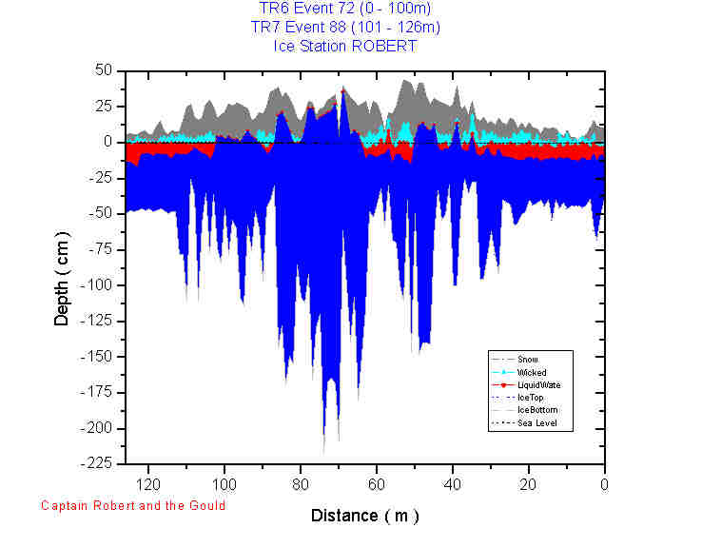
Figure 6. Ice and snow thickness transect at Ice Station 5 (IS-Robert) (plotting courtesy of B.Elder and K.Claffey).

Snow Pits
Twenty-three snow pits were completed at the listed ice stations in conjunction with OG-0241for characterization of snow crystals, density and temperature profiles. Subsamples of snow were obtained from vertical profiles in these pits for later Δ¹⁸O, salinity and nutrient determinations (see OG-241 report).

Ice Cores
The variations in the vertical and horizontal distributions of ice properties and SIMCO at scales of centimeters to ~100 m were assessed by sampling ice cores. Often these cores were collected in a nested sampling regime at horizontal scales of 50 cm up to 100 m at each of the extended process station (Robert and Billy; see station diagrams).
Cores for the determination of the vertical distributions SIMCO biomass were sectioned at 5 to 20 cm intervals, melted (using filtered brine or seawater as an osmotic buffer, Garrison and Buck 1986; Fritsen et al. 1994) and routinely subsampled for evaluating the chlorophyll a and bacterial abundance. A subset of these sections were sampled for the determination of particulate organic carbon and nitrogen. Microscopic examinations of the vertical profile are being completed by primarily BG-244.
Altogether, 146 cores were obtained which were processed for either structure determinations and/or biomass and microbial composition studies as well as stable isotope analysis. Coring and processing was accomplished in a coordinated manner with BG-244 and OG-241 in order to ensure that ice physical structure and chemistry information can later be linked to biotic composition and microbial consortia structure.

Table 3. Summary statistics of depth integrated chlorophyll a (chla), ice core length (H) and average chla concentrations in ice cores that were collected and processed for determinations of chlorophyll a and later determinations of POC/PON and bacterial abundance and biomass.

Statistic |  | H  (cm) | Depth Integrated Chla  (mg m⁻²) | Chla Concentration  (mg m⁻³)
Mean |  | 59 | 0.675 | 1.041
Standard Error |  | 5 | 0.126 | 0.136
Median |  | 43 | 0.195 | 0.410
Standard Deviation |  | 41 | 1.069 | 1.155
Sample Variance |  | 1669 | 1.142 | 1.335
Kurtosis |  | 3.89 | 7.086 | 1.902
Skewness |  | 0.93 | 2.626 | 0.504
Range |  | 210 | 5.032 | 5.366
Minimum |  | 13 | 0.017 | 0.019
Maximum |  | 223 | 5.049 | 5.384
Count |  | 67 | 72 | 72

Ice instrumentation
During the extended ice stations (Robert and Billy). Snow stakes and thermsitor strings were deployed in the ice and slush in an effort to document the dynamics of snow deposition metamorphosis and freezing dynamics that influence sea ice-based carbon production and dynamics. Snow stake and ice thickness arrays were deployed near buoys (deployed by OG-241) in hopes that they would be revisited during the following LTER-ice cruise. Short term deployments of thermistors in slush layers helped document the freezing dynamics (Figure 7) of this sea ice biota’s habitat that will aid in determining the occurrence and timing of flood-freeze cycles in the region.

CTD operations
In conjunction with the ice station work, BG-235 worked in conjunction with RPSC personnel and OG-241 to obtain depth profiles of conductivity, temperature, nutrients and chlorophyll a biomass through the CTD and Rosette deployments (see Appendix 1). These operations were conducted to aid in the description of the upper water column parameters and dynamics as they affect the ice-ocean interactions that, in turn, help determine the ice mass balance, the ice biota dynamics and the coupling of larval krill to ice and ice biota. Nutrient data is being compiled by RPSC subcontractor for nutrient chemistry while the CTD information was compiled and distributed by RPSC personnel through the cruise CD-ROM.
Figure 7. Temperatures of snow and slush (slush at 3 cm to 15 cm) during an active freezing event at Ice Station Robert. Temperature data show the propagation of a freezing front through the 12 cm slush layer that was present on top of ~35 cm of consolidated sea ice. Freezing of the slush layer occurred over 48 hours at this site.

BG–237 Harvey

Field team R. Harvey and S. Ju

Our field team included Rodger Harvey and Se-Jong Ju. The primary objective of this cruise was the sampling of adult krill (E. superba) for determination of population age structure using biochemical markers. Lipid composition of individuals will also be included to examine dietary history. Several MOCNESS tows on 31 July and 2 August near the southeast tip of Adelaide Island (vicinity of station 32) were successful in collecting the minimal number of adults and other size classes to allow dissection of eyestalks for morphometric measures and onboard analysis. After dissection of eyestalks, individuals were frozen for lipid analysis at our home institution. Significant ice cover was often a hindrance, but additional tows were conducted at night in open water leads to depths of 200 m. For all tows in which adult animals were found, stratified sampling observed animals throughout the upper water column (60-200 m) with adults concentrated below the thermocline (ca. 120 m). In total, about 500 animals in excellent condition for analysis were collected through 4 August. The original science plan called for a return to the polynya southeast of Adelaide for sampling later in the cruise, but extensive sea ice station work and changing weather conditions prevented the ship from returning. As a result, our hopes for a complete sample suite (up to 900 animals) were not met and will moderate the interpretation of results. Several tows were conducted as a last ditch effort near French Passage as the ship transited towards Palmer Station, but only larval animals were captured which were of little use. Although compromised in number, the length frequency of animals undergoing analyses for age markers show good coverage of size ranges expected for adults and are illustrated below (Figure 8).
Figure 8. Animal length (measured from eye to tip of telson) verses the number of E. superba collected for age marker analysis. Subadults (<20 mm) were excluded from collections.

Although originally a secondary priority for the cruise, our on-board HPLC system allowed water samples and ice cores to be examined for pigment distribution and concentration. Our objective for these analyses was not a detailed survey of phytoplankton in all areas, but rather an examination of phytoplankton community distribution (as reflected by pigments) in areas where animals might be feeding. To accomplish this, water at several depths from eight CTD casts was collected and pigments distributions analyzed immediately. Sea ice cores in surface floes in the vicinity were also collected to provide information on phytoplankton distributions and comparative information with ice algal communities. With the help of Quetin’s group (BG-244) samples of phytoplankton growing on horizontal surfaces under the sea ice were also obtained. An example of results obtained during the cruise is shown below for a single CTD cast (event 102, Figure 9). It is apparent that phytoplankton numbers in the austral winter are reduced than typically reported for summer waters, but accessory pigments do show a greater diversity of taxa than expected. Analysis of sea ice cores observed even greater diversity, including the presence of dinoflagellates, which were absent from water samples (data not shown). An increased detrital component is also seen in the increased ration of phaeopigments verses chlorophyll in deeper waters (Figure 9).
In summary, our group would consider the LMG01-06 cruise a modest success. Although total sample numbers are compromised, the adult krill collected show good range in size structure that is encouraging. Final analysis and calibration of age markers for this group of E. superba will provide an important baseline for further work in the region. Ancillary information on pigment distributions will be used by our project to link food resources to animal feeding history. It can also provide comparative information with other groups interested in phytoplankton dynamics and comparative measures of community structure.

Figure 9. Depth profiles of chlorophyll-a and accessory pigments obtained by HPLC during LMG01-06. Water samples were collected by CTD, immediately filtered and extracted for analysis. All pigments show a maximum concentration below surface waters, followed by a rapid decrease in concentration with depth.

BG-244 Quetin and Ross
Field team: L. Quetin, C.Boch, S. Dovel, A. Gibson, T. Newberger, L. Quetin, S. Oakes, M. Thimgan and J. Watson

No report submitted.

OG-241 Martinson, Perovich, Smith

Field team: B. Elder, S. Stammerjohn and K. Claffey

Optical Environment of the Western Antarctic Peninsula Region
To determine the “Optical Environment of the Western Antarctic Peninsula Region,” you must first determine what the sea ice is that is found there. To characterize the sea ice in the Marguerite Bay area, we sampled the different ice types in conjunction with members from BG-235-0 Fritsen (Sea Ice Microbial Communities) and also BG-244-0 Quetin/Ross (Winter Ecology of Larval Krill: quantifying their interaction with the pack ice habitat). Ice work was done in a manner such that the data sets will all complement one another. Wherever an ice core was taken for one group, similar ice cores were obtained for the others to create one complete data
The schedule allowed for us 12 sea ice stations. At nine of these stations, a full complement of samples was obtained for snow and ice properties as well as distribution of snow and ice thickness. At the remaining three stations only snow, ice cores and brine were collected, a thickness transect was not performed due to time and ice limitations. Snow pits were conducted to measure the temperature, salinity, density and Δ¹⁸O profile through the snow pack as well as a visual description of grain size, crystal form and hardness of each layer of snow. Many of the sites had an ice surface that was below freeboard due to snow loading. This created a salty slush layer on top of the sea ice that had salinities well above the salinity of seawater and were 10-20 cm thick in places. This slush layer also had a wicked layer of snow above it where the snow was wicking the brine up into the snow pack, 10 cm in places. Depending on our time at a station we took a series of cores at a number of locations. The short stations we took 1-2 sets of cores. Sectioning into discrete samples was performed on the ice to prevent loss due to brine drainage. Visual documentation was recorded on each core of its crystal type as well as bubble layers and brine features were noted. Two of the cores were used for our purposes. The first core we measured the ice temperature profile of the core immediately after it was extracted from the ice. It was then sectioned into 5-cm sections and melted for salinity and Δ¹⁸O samples. The BG-235 group also sampled these sections for nutrients and chlorophyll. Our other core was bagged for thin sectioning on the ship to determine its sea ice type and grain size. From each of these cores a thick section and a thin section were prepared. The thick sections allow one to document the bubble layers and brine features found in the cores that are difficult to see in the field. A thin section was also prepared by mounting the ice on to glass plates and using the band saw and a hand plane, thin them down to a thickness thinner than the glass plate itself. By placing the section under cross-polarized light you can see the crystal sizes and form. Sea ice that is grown under quiescent conditions will form long columnar crystals where ice grown under turbulent conditions will form small granular crystals. The sections along with the Δ¹⁸O will help to determine the snow ice fraction at the surface. Snow ice and granular or frazil ice is difficult to distinguish in thin section as the grain sizes are very similar.
At each of these nine stations, we also performed thickness transects to measure the distribution of snow and ice thickness. Along these transects we measured the depth of the snow, liquid water on the surface, wicked snow layer, ice and the freeboard layer as well as the snow/ice interface temperature at 1-m intervals. Where the sea ice flow permitted, we would measure from a flat level ice over a ridged/rafted section and back on to another level ice section such that we would be sampling all the ice types that were present on the floe. At the long-term stations, we positioned the transect such that the diving operations were performed near or along our transects so that our data can be compared. This is quite beneficial to our program as in areas where the ice sheet seemed flat and undisturbed, our thickness drilling produced erratic thickness and by viewing the dive videos it confirmed our thoughts that there were blocks of sea ice trapped beneath the level ice with no effect in surface topography.
During the first long-term ice station, we were able to observe the freeze back of this slush layer to form 15-20 cm of new ice on the surface. The freeze back of the surface layer happened in a 3-day period, which had the net result of a 10-20 cm thicker ice sheet. This is in contrast to our other long-term station where when we arrived the ice surface was already cold with air temperatures around –15°C. We were able to observe thermodynamic ice growth of 3-4 cm new ice on 35-cm thick ice over a duration of four days. At these long term stations a nested array of ice cores and snow pits were measured in a triangular array. Cores were taken at 10-12 locations determined by distance in an array fashion. All measurements were taken on these samples as described above. We sampled ice cores from the same location at both of these sites, at the beginning of our stay at the ice station and again at the end of our stay to compare all measurements.
Another aspect of our studies, which all this supports, is the optics of the different sea ice types found in the region. When weather and day light permitted, snow and ice albedo and transmission measurements were taken. At only one site was the surface frozen where we could measure the combined snow and ice albedo and transmission and then shovel the area and re-measuring to subtract out the snow component. This will allow us to sort out what component the snow and ice have individually in the transmission of light into the ice and water column for the organisms to grow. Our measurements were hampered due to blowing snow which we experienced nearly every day and the fact that we needed to be stopped near solar noon as the sun angle is low this time of year, so only a limited number of optics measurements were performed.
To measure the seasonality of the ice sheets we deployed five drifting buoys, three of which had to be transferred to the N.B. Palmer due to the limitation on where the Gould could maneuver without getting stuck or taking up multiple days to get there. Three of these buoys are what we call “simple” buoys. They transmit data back via Service ARGOS. We receive hourly air temperature, barometric pressure, and GPS position readings. Along with these buoys we have deployed an array of bamboo stakes in a manner such that if these sites are revisited during the next LTER cruise. Snow and ice thickness can be re-measured at each stake, which also has a reference mark on them to measure mass balance at each of the 10 stakes with growth/melt data for both the top surface of the ice as well as the bottom surface of the ice. Two of the buoys are considered “complex” buoys. These buoys also have the bamboo array located next to them as well as the thickness transect marked for further measurements by the LTER. The buoys are considered complex as they have additional sensors. They record data internally hourly which if retrieved will give us a complete data set. The data that they transmit at a 3-hour interval is air temperature, snow accumulation with an acoustic device, bottom ice growth with an under water acoustic device, a flourometer and a string of thermistors that record temperature at 5 cm intervals from the air, into the snow, through the ice and into the water later immediately below the ice. Through Service ARGOS, a position is calculated during transmission that is not as accurate as GPS but will allow us to track its position and find the site for follow up measurements and retrieval of the buoys. At one of the buoys in the mouth of Marguerite Bay we also deployed additional sensors. There are three radiometers: one mounted 1.5 m in the air, one mounted at the bottom of the ice sheet, and one mounted 3.5 m below the bottom of the ice sheet. These record internally hourly but due to transmitting limitations, we can only transmit data six times per day with one set at solar midnight for a dark reading and the remaining five measurements hourly centered around solar noon.
While underway in the ice pack, hourly ice observations were conducted using the ASPeCt protocol. These measurements were limited during dark hours but were performed to the best of our abilities with lighting from the ship. These observations allow us to take our ice station data and extend that to the broader area that we traveled in Marguerite Bay. We now have a record of the three predominant ice types at each hour with snow and ice thickness, type, floe size, and topography recorded. Also recorded was the open water content. By doing this we have records of the gradient of ice conditions in and out of the ice edge and also documentation of the edge of the Adelaide Polynya.

CRUISE PARTICIPANTS

Science Party (Name, Institution)

BG-232-0 Foraging Ecology of Crabeater seals
Costa, Daniel University of California Santa Cruz
Gales, Nick Australian Antarctic Division
Trumble, Steve University of Alaska, Fairbanks
McDonald, Brigette California State University at Sonoma

BG-234-0 Winter Foraging Ecology of Ad☺lie Penguins
Fraser, Bill Polar Oceans Research Group

Muth, Steve Polar Oceans Research Group

BG-235-0 Sea Ice Microbial Communities
Fritsen, Chris Desert Research Institute
Memmott, Jeramie Desert Research Institute
Marschall, Sarah Desert Research Institute

BG-237-0 Biochemical Determination of Age and Dietary History in the Krill Euphasia superba
Harvey, Rodger CES, University of Maryland
Ju, Se-Jong CES, University of Maryland

OG-241-0 Optical Environment of the Western Antarctic Peninsula Region
Elder, Bruce Cold Regions Research Engineering Laboratory
Stammerjohn, Sharon Lamont-Doherty Earth Observatory
Claffey, Kerry Cold Regions Research Engineering Laboratory

BG-244-0 Winter Ecology of Larval Krill: quantifying their interaction with the pack ice habitat
Quetin, Langdon University of California Santa Barbara
Boch, Charlie University of California Santa Barbara
Newberger, Tim University of California Santa Barbara
Oakes, Stephanie University of California Santa Barbara
Thimgan, Michael Scripps Institution of Oceanography
Watson, Jordan University of California Santa Barbara

Nutrients
Morello, Aaron University of Washington

Raytheon Polar Services Technical Support (Name, Position)
Newyear, Karl Marine Project Coordinator
Alesandrini, Stian Marine Technician
Spillane, Josh Marine Technician
Martin, Peter Electronics Technician

Officers and Crew (Name, Position)
Verret, Robert II Master
Bouzigard, Morris. J. Chief Mate
Snyder, John 2nd Mate
Arrigoni, Alan 3rd Mate
Murphy, Micahel Chief Engineer
Boswell, Howard 1st Engineer
Tompsett, Gerald 2nd Engineer
Meneses, Joseph Oiler
Dasoy, Donde Oiler

Naraga, Fernando Seaman
Ninon, Roy Seaman
Padasas, Dionito ` Seaman
Albornoz, Luciano Seaman
Stone, Mark Steward
Lucas, Rodolfo Steward
Agonias, Romeo Gallyhand

