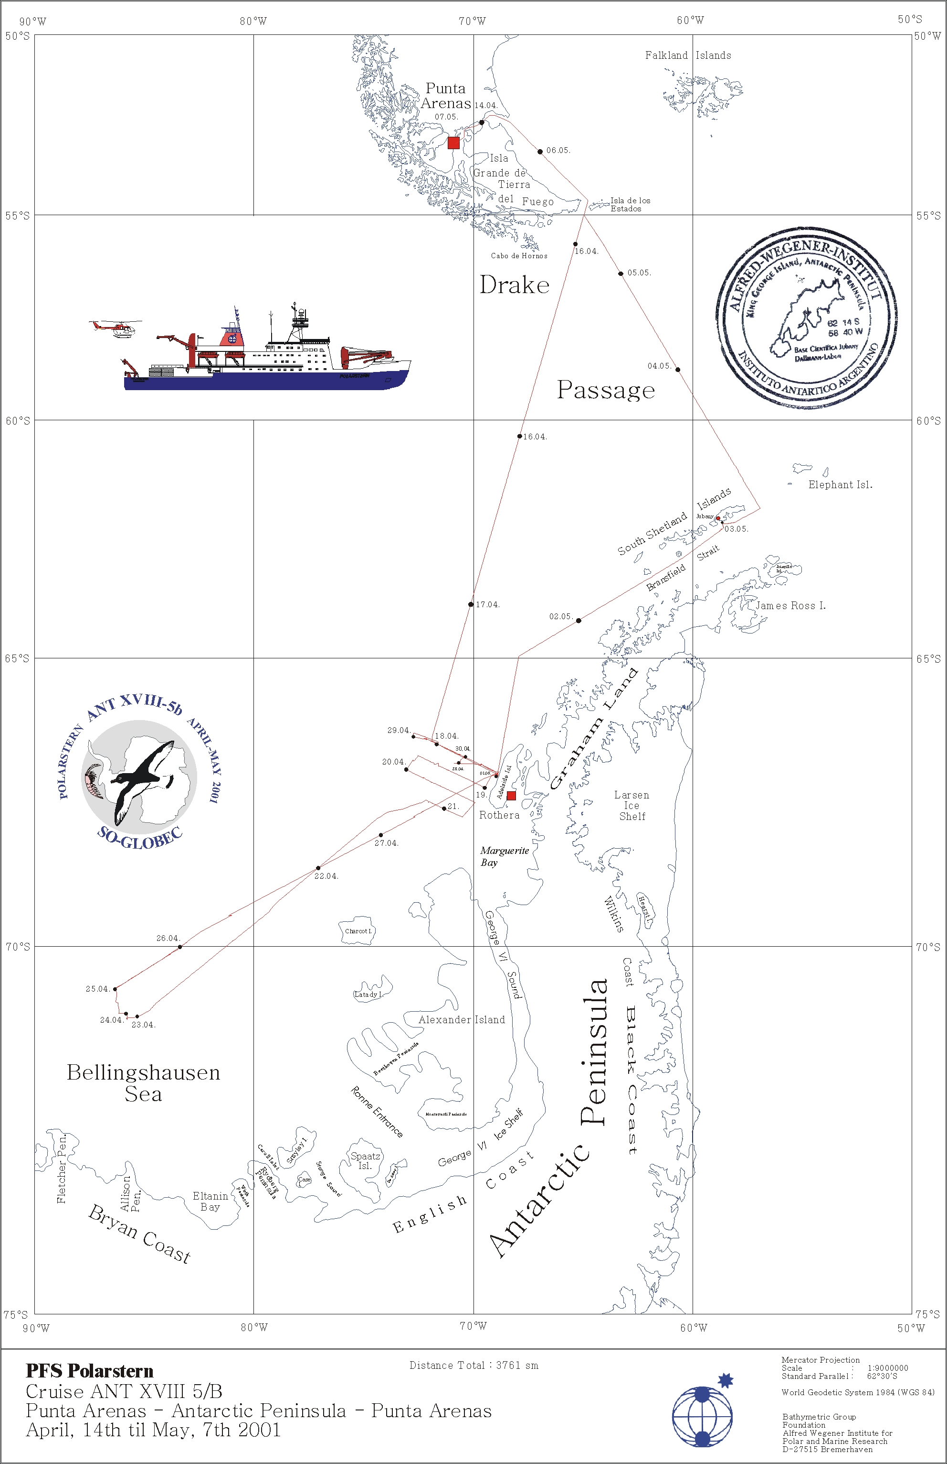
Figure 1. Polarstern AntVIII5b cruise track and sampling stations

Figure 6. Polarstern AntVIII5b Cruise track and all cetacean sightings

Figure 2. Polarstern AntVIII5b cruise track and inset of Figure 8&9 with all cetacean sightings. Species codes: 7=humpback – yellow circle; 13&59=Lagenorhynchus sp. – green diamond; 4,91&92=minke – black star; 9,64,65,67=unidentified whale – yellow triangle

Figure 3. Polarstern AntVIII5b in ice cetacean sightings – In ice helicopter surveys and ship based visual survey 25 & 26 April 2001. Black star=minke; yellow triangle=probable minke. Bold red line = cruise track. Fine red lines = helicopter surveys. Yellow line = oceanic fast ice edge.

Figure 4. Polarstern AntVIII5b cetacean sightings – Adelaide Island/Rothera helicopter survey 1 May 2001. Yellow circle=humpback, black start=minke. Bold red line = ship cruise track. Fine red lines = helicopter survey tracks.

