IWC-SO GLOBEC collaboration
L M Gould LMG 01-03
2001
(exceprts from the Cruise Report R/V Gould LMG01-03)

Marine Mammal visual survey, passive acoustic census and biopsy sampling

5.1 Acoustic Census of Mysticete Whales

Most large whales produce distinctive calls such that passive acoustic methods can be used to study their distribution, behavior, and minimum absolute abundance. The repetitive call of the ordinary blue whale is ideal for long-range signal transmission. Although blue whale calls vary by geographic region, each population produces a characteristic low-frequency (~20 Hz) repetitive call of roughly 10 to 20 seconds duration, sometimes with multiple components. The detection range for blue whale calls from a simple bottom recorder is typically 20 km, with longer ranges possible if one applies matched filter techniques. The long-term nature of seafloor recorder deployments allows for a statistically significant number of acoustic encounters, even with a widely dispersed whale population, assuming whales call roughly ten to fifty percent of the time. The recordings will likely also include sounds from minke, right, fin and humpback whales.

Mysticete whales will be detected via reception of their calls on passive, bottom-mounted acoustic recorders. Detection of whale calls via moored passive acoustic recorders has proven quite effective during recent studies, especially for blue and fin whales. New technology, that of long-term deployments of autonomous low power recorders makes an acoustic survey of mysticete whales in remote locations practical. Deep water is desirable partly because the ambient noise, which largely is produced at the surface, is reduced at depth and also because acoustic travel paths will interact less with the seafloor which absorbs acoustic energy. The long-term nature of seafloor recorder deployments allows for a statistically significant number of acoustic encounters even with a widely dispersed whale population, assuming whales call roughly ten to fifty percent of the time.

Given the great uncertainty in the numbers of blue whales in the Southern Ocean (500 to 5000), and in the subspecies to which they belong, we believe the minimum census estimates which can be provided by acoustic monitoring is a key goal of the proposed project. If we were to have 800 acoustic contacts per season, for instance, it would be clear that current blue whale population estimates are severely underestimating the actual populations. Even in the case where we would obtain 80 acoustic contacts per season, in keeping with the current estimates, we should be able to provide some estimate of which geographic areas and or subspecies the animals are from. Application of the techniques of point transect theory to the results of the survey where each acoustic contact is assigned a range should allow a minimum census estimate, the primary factor which will remain to be answered from other combined visual and acoustic data being the percent of whales calling during a time constant.

The second fundamental goal of this work will be minimum population estimates and seasonal occurrence profiles for fin whales and humpback whales. Other species such as minke whales and sperm whales may be detected, but are expected to be so infrequent as to make population density estimates unreliable. Perhaps the most important overall result of this work will be to establish an acoustic detection baseline from which to measure future changes in relative abundance of Southern Ocean mysticete whales.

We deployed eight seafloor acoustic recorders, each with a hydrophone that is floated about 5 m above the seafloor. These instruments will record continuously at 500 samples per second for fifteen months, writing the data to 36 Gb of computer hard drive in each instrument. The recorders have a 16 bit dynamic range and are powered by lithium double D size batteries, which are placed inside high tensile aluminum pressure cases. The seafloor recorders use a system of drop weights, Benthos glass balls and an acoustic release for recovery.

Throughout the cruise we deployed and recorded 36 directional sonobuoys and two broadband sonobuoys both randomly and when whales were sighted, as a means to record and thereby `groundtruth’ mysticete whale calls in this remote region. Recordings were obtained from humpback, minke and fin whales during the cruise. No blue or right whales were sighted or heard during this cruise.

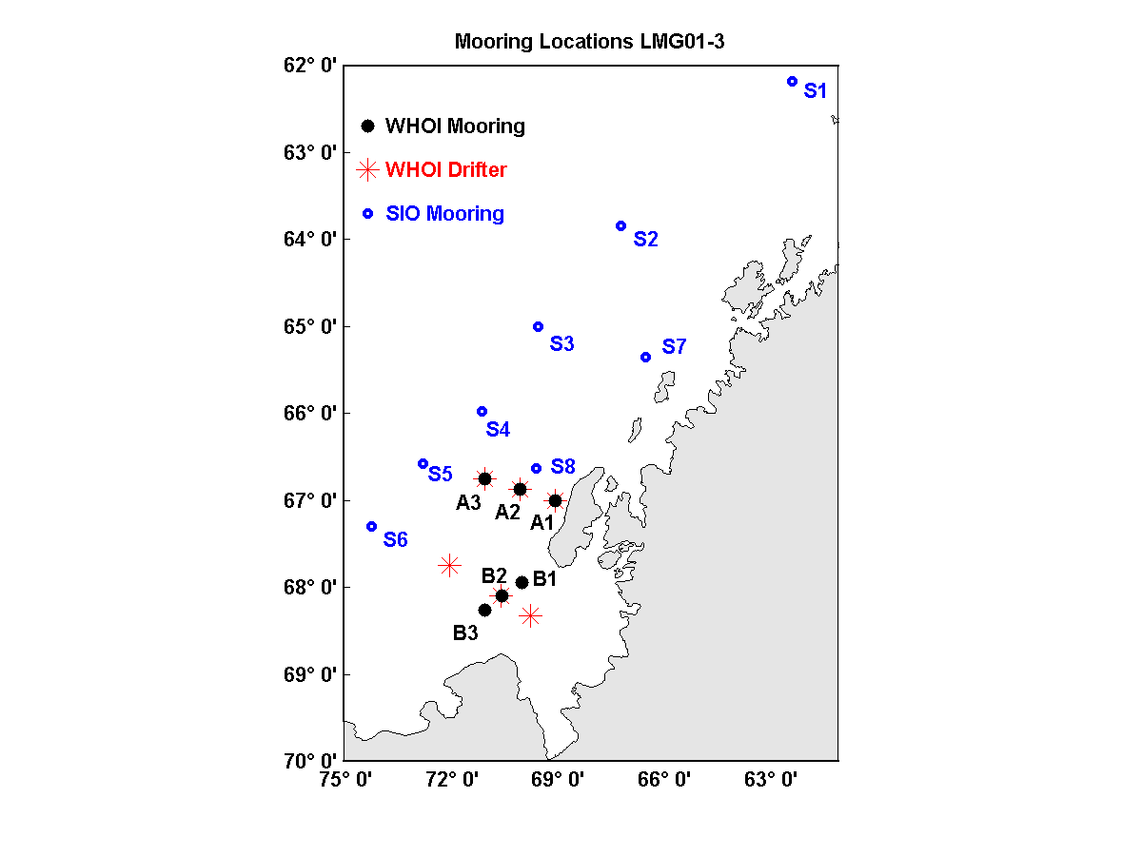

5.2 Marine Mammal Visual Survey, Photo Id And Biopsy Summary

A visual survey for cetaceans was conducted on LMG01-3 during daylight hours on all days when weather conditions allowed. Searching was conducted by the IWC observer (Deb Thiele) and Sue Moore with assistance from the rest of the acoustic mooring team. Sightings were recorded on a laptop based Wincruz Antarctic program which also logged GPS position, course and ship speed automatically. Seals, seabird concentrations, ice concentration, SST and depth were also recorded on the program. Survey effort generally commenced at first light from the outside bridge wings and/or inside the bridge (weather dependent) and ceased at dark. Visual surveys alone were conducted during the oceanographic and acoustic mooring components of the cruise. Large numbers of humpback whales were observed during the afternoon transit across the Bransfield Strait.

Five days of ship time were allocated to conduct cetacean survey (including closing on sightings, biopsy, photo identification and sonobuoy deployment) from first light on Tuesday 3 April to end of day Saturday 7 April. The weather improved for this part of the survey, with calm seas and a lifting of the Peninsula cloud blanket providing us with some rare sunny days! During this time the ship traversed the inside channels to the north of, and including, Adelaide Island. In Matha Strait two large feeding groups of the dark shouldered minke whale were sighted (total of 80 animals). Photographs were obtained and biopsies of four minkes from the largest group were taken. On entering the northern end of Marguerite Bay, just near Rothera Station, a large group (30) of killer whales was sighted. The killer whales broke into sub groups and traveled north past the ship with many accompanying fur seals, and a minke whale. One humpback was also seen in the vicinity. The ship took a southwest course to Neny Island and then headed across the bay and towards Palmer Station on a course close to the coast and inside the islands from Matha Strait onwards. Two pairs of humpbacks were located late in the afternoon on 7 April, with photo id and biopsy obtained from one pair. Total biopsies taken: 5 minke (one from a group of 7 and 4 from the feeding group of 50) and 5 humpback (one from one pair and both animals from another two pairs).
Total species | Total sightings/animals
Fin whale | 1:3
Minke ordinary | 9:91
Like minke | 5:14
Hourglass dolphin | 1:4
Unidentified cetacean | 1:1
Unidentified large whale | 3:5
Killer whale | 4:53
Ziphiidae | 2:5
Humpback whale | 38:81
Humpback whale and like fin whale (mixed group) | 1:12
Undetermined minke whale | 18:40
Like fin whale | 1:3
Unidentified whale | 4:4
Total | 88:316

Table 4. LMG01-3 marine mammal observations.

