NBP0103
24 April – 6 June 2001

SO GLOBEC
International Whaling Commission

Cetacean Visual Survey and Biopsy

Cruise Report

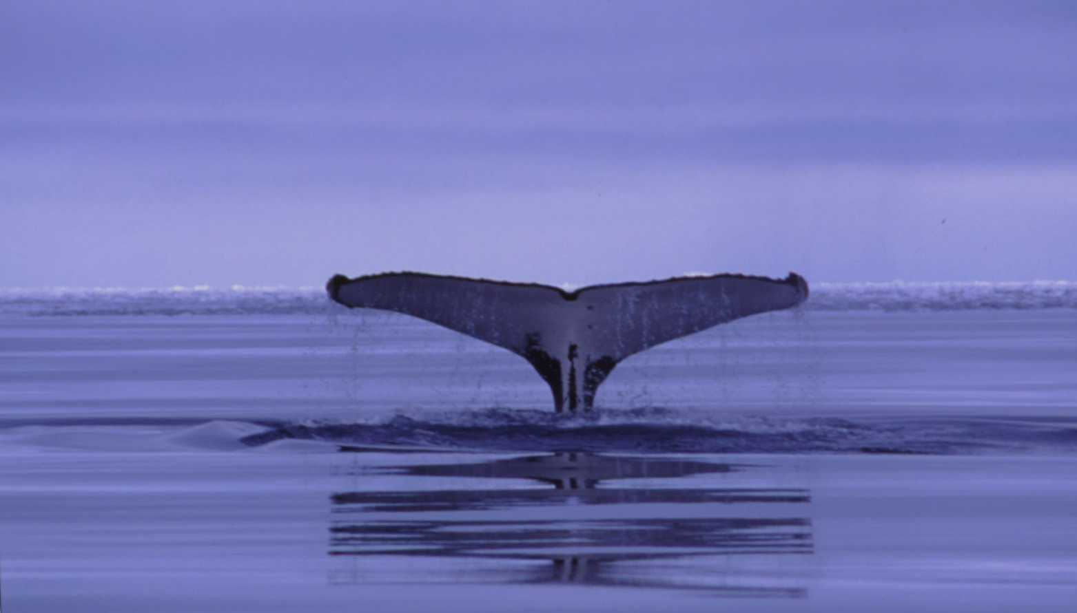
Ari S. Friedlaender

Introduction
Recently, the International Whaling Commission (IWC) developed proposals for collaborative work in the Southern Ocean with the Commission for the Conservation of Antarctic Marine Living Resources (CCAMLR) and the International Global Ocean Ecosystem Dynamics (GLOBEC) program under the IWC Southern Ocean Whale Ecosystem Research (SOWER) program. This research program has the long-term aim to “define how spatial and temporal variability in the physical and biological environment influence cetacean species in order to determine those processes in the marine ecosystem which best predict long-term changes in cetacean distribution, abundance, stock structure, extent and timing of migrations and fitness’.
This objective is being pursued through collaboration with GLOBEC and CCAMLR using multidisciplinary ecosystem approach to data collection, analysis, and modeling. The IWC also recognizes that it lacks the data to determine baseline patterns of distribution (and the biological and physical processes responsible for such patterns) of baleen whales from which to judge the potential effects of climate change. Therefore, three further objectives have been defined by the Commission. They are: to characterize foraging behavior and movements of individual baleen whales in relation to prey characteristics and physical environment, to relate distribution, abundance and biomass of baleen whale species to same for krill in a large area in a single season, and to monitor interannual variability in whale distribution and abundance in relation to physical environment and prey characteristics.
SO-GLOBEC studies provide the ideal platform for such long-term studies, where scientists from a range of disciplines can conduct intensive focussed studies, within the framework of long term data synthesis and planning. Given the shared objectives among the IWC, GLOBEC and CCAMLR, the IWC has determined that the most effective means of investigating these ecological issues is to focus a considerable body of cetacean research within the framework provided by these programs (taken from D. Thiele).
The first of the “Predator Science Questions” in SO-GLOBEC has been formulated as: How does winter distribution and foraging ecology of top predators relate to the distribution and characteristics of the physical environment and prey (krill) (taken from J.A. van Franeker).

Methods
Standard IWC methodology for multidisciplinary studies will be used throughout all GLOBEC collaborative cruises. This will involve experienced cetacean researchers conducting line transect sighting surveys throughout daylight hours in acceptable weather conditions. Data are recorded on a laptop based tracking program (Wincruz), and photo and video records are also obtained for species identification, group size ,verification, feeding (and other behavior), ice habitat use and individual identification (taken from D. Thiele).
During this cruise, observations were made from the ice tower or the bridge level by a single observer (AF). When conditions permitted, the observer was outside along the cat-walk of the ice tower, otherwise, observations were made from inside. Effort was focused 45° to port and starboard of the bow ahead of the vessel, while also scanning to cover the full 180° ahead of the vessel. °. In ice the method was adjusted to include searching in behind the vessel track as well, in order that cetaceans and seals hidden by ice would be detected more readily. The observer used a combination of eye and binocular (7x50 Fujinon) searching. Effort would commence when the following conditions allowed: appropriate daylight, winds less than 20 knots or Beaufort Sea State less than or equal to 5, visibility greater than 1 mile (measured in the distance a minke whale blow could be seen with the naked eye as judged by the observer) and the ship actually steaming.
Sightings were recorded on a laptop based Wincruz Antarctic program which also logged gps position, course, ship speed, and a suit of other environmental and sighting conditions automatically. Visual observations were made both during the station-transect portion of the trip, as well during transit. When possible, photographic and/or video documentation was made of each sighting for later use in individual identification, species confirmation, and habitat description.
A second component to the marine mammal work is biopsy sampling from small boats. On the occasion that weather conditions, daylight, timing, and whales were present, biopsy sampling was attempted from Zodiacs. Samples were obtained with a Barnett Wildcat Crossbow equipped with custom made floating bolts, and screw-on hollow point biopsy plugs. The bolts are designed to penetrate the skin and blubber (depending on the size of the plug; either 1inch or 0.5 inches) to the end of the plug, where the float begins, and bounce out of the whale, securing a sample with three small barbs inside the plug. Skin samples are preserved in dimethyl sulfoxide solution and will be send to the National Marine Fisheries Service, Southwest Fisheries Science Center for genetic analysis. Blubber samples will be frozen for later use in contaminant, pesticide, heavy metal, etc. analysis.

Results

Sightings
Generally, sighting conditions during the cruise were poor. The appropriate combination of environmental and ship conditions did not lend to good conditions. Yet, nearly 80 hours (79:33) of sighting effort were made during the entire cruise. Of this time, 45:30 was made during the survey grid.
In Antarctic waters (south of 60°S), 43 cetacean sightings of 67 animals were made (Figure 1). These include 19 sightings of 30 humpback whales, Megapatera novaeangliae, 22 sightings of 33 minke whales, Balaenoptera acutorostrata, 1 sighting of 3 ‘like’ humpback whales, and 1 sighting of 1 unidentified whale (Table 1).
More specifically, within the study area as defined by the survey grid, 18 sightings of 27 humpback whales (Figure 2), 19 sightings of 30 minke whales (Figure 3), 1 sighting of 3 ‘like’ humpback whales, and 1 sighting of 1 unidentified whale were made (Table 2).

Biopsy
On the evening of 24 May, sonobuoys recorded several humpback whales relatively close to the ship (C. Berchock pers. comm.), and whales were seen in the ship’s lights as the RVIB Nathaniel B. Palmer traveled north along the west coast of Alexander Island. At first light the ship was approximately 2 miles north of where the whales were seen. Ship’s time was dedicated to biopsy sampling for the day, and AF decided to steam back to where the whales were previously seen. At 0930 whales were sighted in an area with bands of brash ice several miles off the coast. Weather conditions were optimal for surveying and small boat work. Zodiacs were deployed for work at 1030. In the area of the ship (68.75S, 71.35W) were 3 pairs of humpback whales and one single humpback whale, one group of 2 minke whales and one group of 3 minke whales. The whales appeared to be tracing back and forth, perpendicular to the coast in a 2-3 mile area. Photo-ID pictures were taken of each of the whales in the area, save 2 minkes and one humpback whales that were not approached. Video footage was taken of each approach, shot taken, and each whale’s behavior (thanks to Mark Christmas, National Geographic Society). Biopsy samples were obtained from 3 humpback whales and 1 minke whale. Only one sample was taken from each group of animals approached. Skin samples were taken from all 4 whales, while blubber samples were taken from 2 of the humpbacks and the minke whale (Table 3).

Preliminary Findings/Discussion
As stated earlier, a primary research objective of the cetacean studies within SO GLOBEC is to determine the winter distribution and foraging ecology of baleen whales in relation to the characteristics of the environment and the distribution of their prey. Sightings data from this cruise show only humpback (Megaptera novaeangliae) and minke (balaenoptera acutorostrata) whales present in the study region in the austral fall and winter. Sighting numbers for both species were nearly equal, suggesting that both over-winter around Marguerite Bay in similar concentrations. Correlation of cetacean distributions with concurrent hydrographic distributions show whales associated with: 1) the southern boundary of the Antarctic Circumpolar Current, 2) the frontal boundary between intrusions of warm Upper Circumpolar Deep Water and continental shelf water, and 3) the frontal boundary between inner shelf coastal current and continental shelf waters (E. Hofmann pers. Comm., see also Figure 2 in the Hydrography Report). Cetacean sightings were particularly numerous along the frontal boundary formed as the coastal current exits the southern end of Marguerite Bay. Humpback whales were associated with all three frontal boundaries while minke whales were found only along the continental shelf and coastal frontal boundaries. The correspondence between the cetacean sightings and hydrographic features suggests that the austral winter distribution of cetaceans along the west Antarctic Peninsula is not random, but rather is determined by the structure of the physical environment, which in turn determines prey distribution. Continued analyses and collection of cetacean sightings data in conjunction with concurrent prey and hydrographic distributions will allow determination of the causal relationships underlying austral winter cetacean distributions in the Antarctic Peninsula region.

Table 1. Cetacean Sightings in Antarctic Waters (south of 60°S)
 | Sightings | Number
Humpback Whale | 19 | 30
Minke Whale | 22 | 33
Like Humpback Whale | 1 | 3
Unidentified Whale | 1 | 1
Total | 43 | 67

Table 2. Cetacean Sightings within Survey Grid Study Area
 | Sightings | Number
Humpback Whale | 18 | 27
Minke Whale | 19 | 30
Like Humpback Whale | 1 | 3
Unidentified Whale | 1 | 1
Total | 39 | 61

Table 3. Whale Biopsy Samples
Date | WOS # | Species | Skin | Blubber
25 May 2001 | WOS34 | Megaptera novaeangliae | yes | yes
25 May 2001 | WOS35 | Megaptera novaeangliae | yes | yes
25 May 2001 | WOS37 | Megaptera novaeangliae | yes | no
25 May 2001 | WOS36 | Balaenoptera Acutorostrata | yes | yes
Total |  |  | 4 | 3

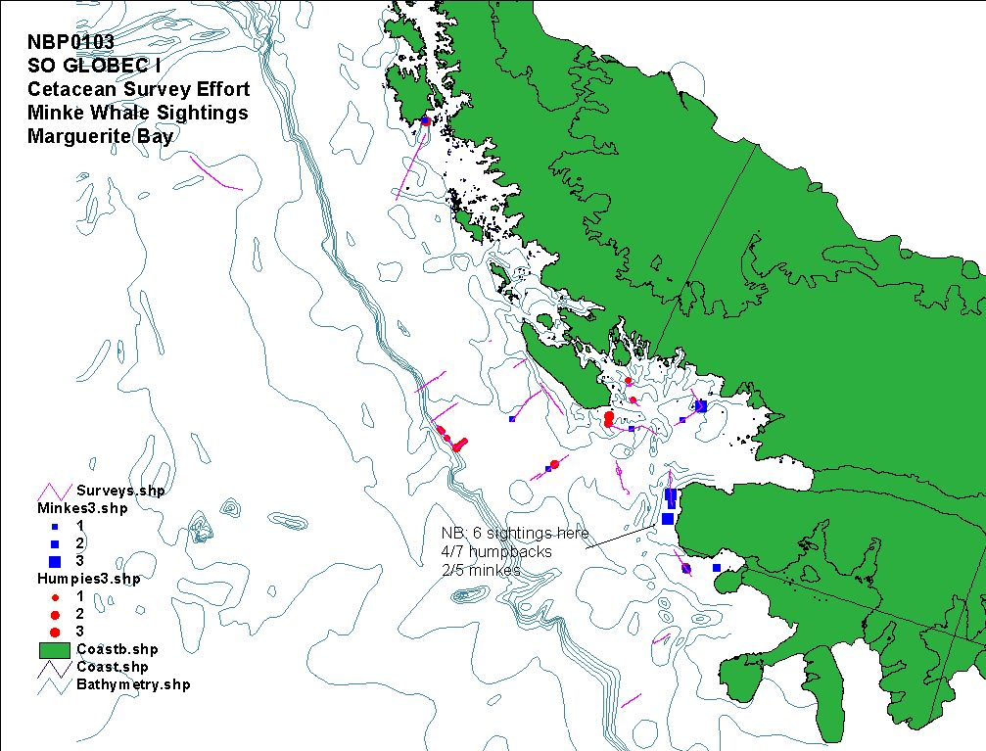
Figure 1. Cetacean Survey Effort Lines and Sightings in Antarctica (below 60°S)

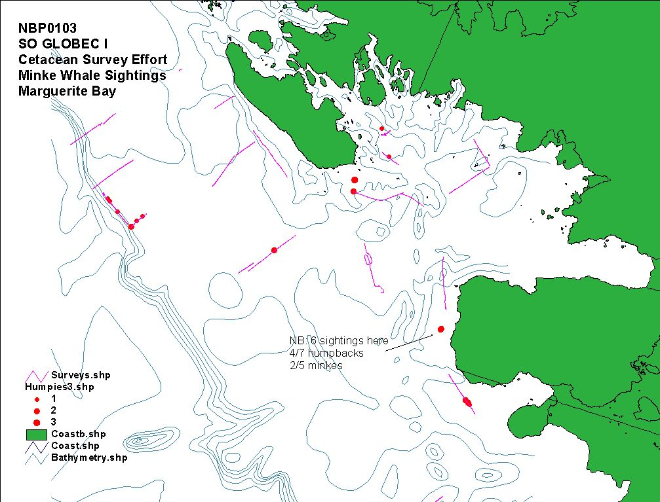
Figure 2. Cetacean Survey Effort and Humpback Whale Sightings

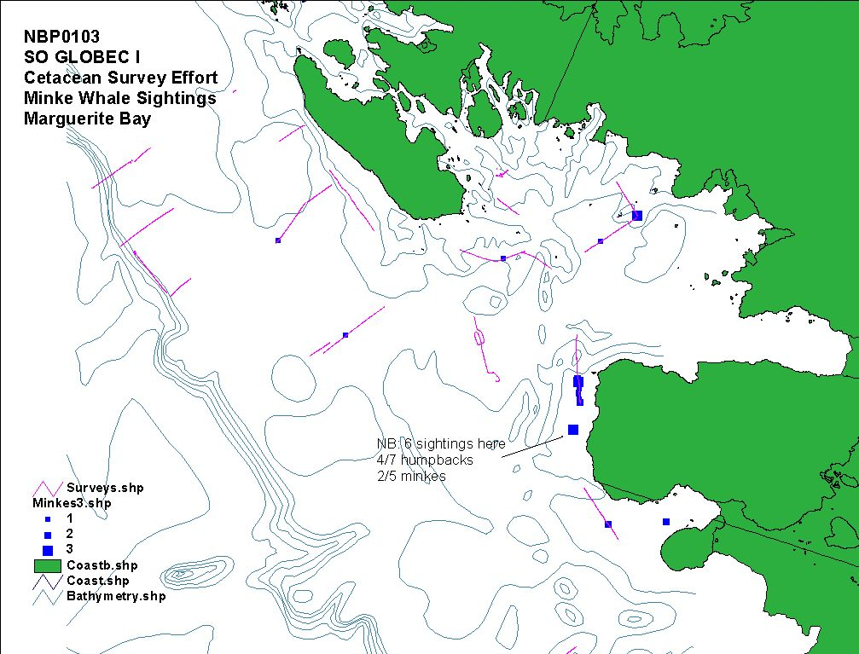
Figure 3. Cetacean Survey Effort and Minke Whale Sightings

